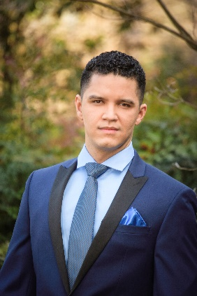
Samuel Ferreira, baritone.
1948 East Gate Drive
Stone Mountain GA 30087
(404) 844 9341
samu.ferreira@hotmail.com
www.samuelferreirabaritone.com

Brazilian baritone, Samuel Ferreira began his musical studies at the age of 12 performing in the “Dom Silvério” Choir. He continued his love of choral music by participating with the Minas Gerais Symphonic Choir, Federal University of Minas Gerais Chamber Choir and Coro Madrigale and Ars Nova Choir.
He was asked to participate in the 2º Trancoso Vocal Academy, with maestro Rolf Beck, from Lübeck where won a scholarship to study in Germany and Poland as part of the Lübeck Choir Academy. He was selected to sing in masterclasses with Francisco Campos, Luciana Monteiro, Paulo Szot, Lucia Duchonova, Magret Honig, Stephanie Blythe and Marcel Boone.
Immediately won the IV Concourse ‘Young Soloists’ Prize with Minas Gerais Symphony Orchestra (2012) and BDMG Young Soloists Competition (2016). His last prizes were in Atlanta Music Club Competition 2017, Georgia NATS Voice Competition 2017, Atlanta Opera Guild Voice Competition 2017 and Encouragement Award in Metropolitan Opera National Council Auditions 2018.
He has performed the roles of Apollo in Mozart’s Apollo et Hyacintus, Slook in Rossini’s La Cambiale di Matrimonio, Don Giovanni in Mozart´s Don Giovanni, Pish Tush in Sullivan´s The Mikado, Vicar Egde in Britten´s Albert Herring and Carl Magnus in Stephen Sondheim´s A Little Night Music. He also was the baritone soloist for Brahms’ Eines Deutsch Requiem and Faure’s Requiem. Up coming season Samuel Ferreira had his debut with The Atlanta Opera Tour singing Figaro in Rossini’s Il Bariere di Siviglia. Also with The Atlanta Opera he had comprimario roles as an Inmate in Heggie´s Dead Man Walking and Un Commissionario in La Traviata. In summer 2019 Mr. Ferreira will have his debut at Lincoln Center in NYC performing Giorgio in La Gazza Ladra with Teatro Nuovo and a tour per Slovakia and Germany with Lubeck Chorakademie performing Bach and Rossini.
Recently Mr. Ferreira received his Bachelor Degree in Voice Performance at Federal University od Minas Gerais, Brazil, in Monica Pedrosa´s voice studio and a Master of Arts Degree in Voice Performance at Georgia State University in Kathryn Hartgrove´s voice studio and Carroll Freeman´s opera studio.
Last update June 2019.

